# Assignment - 2

# CSS Practice Questions (Beginner to Intermediate)

## Question 1: Styling Headings and Paragraphs

Task:  
Write CSS to:  
- Center-align the heading.  
- Set paragraph text color to dark gray.  
- Use font size 20px for the paragraph.

HTML Code:  
<h1>About Us</h1>  
<p>We are a team of developers building cool stuff.</p>

CSS Code:

  <style>

    h1 {

      text-align: center;

    }

    p {

      color: #333333;

      font-size: 20px;

    }

  </style>

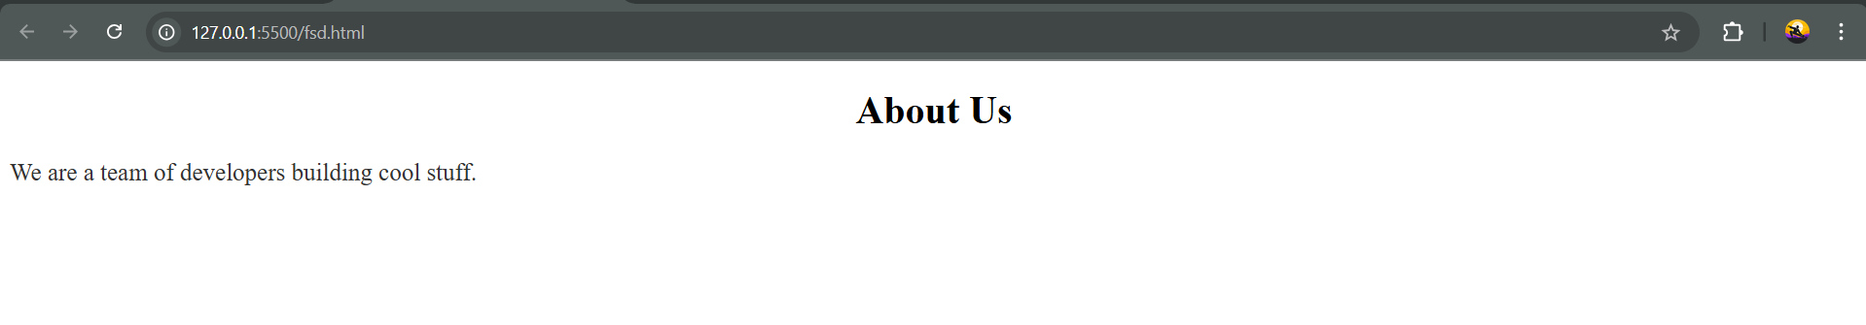

## Question 2: Styling a Navigation Bar

Task:  
Style the links to:  
- Remove underlines.  
- Change color to dark blue.  
- Add a hover effect to change color to orange.

HTML Code:  
<nav>  
 <a href="#">Home</a>  
 <a href="#">About</a>  
 <a href="#">Contact</a>  
</nav>

CSS Code:  
nav a {

text-decoration: none;

color: darkblue;

}

nav a:hover {

color: orange;

}

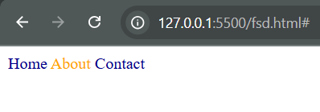

## Question 3: Box Styling

Task:  
Style the box to:  
- Set background to light gray.  
- Add padding of 20px.  
- Add border of 1px solid black.

HTML Code:  
<div class="box">This is a styled box.</div>

CSS Code:

.box {

background-color: lightgray;

padding: 20px;

border: 1px solid black;

}  
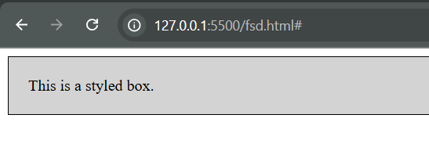

## Question 4: Button Styling

Task:  
Make the button:  
- Rounded with border-radius 10px.  
- Have padding of 10px 20px.  
- Have a background color of #007BFF and white text.

HTML Code:  
<button class="btn">Submit</button>

CSS Code:  
.btn {

border-radius: 10px;

padding: 10px 20px;

background-color: #007BFF;

color: white;

border: none;

cursor: pointer;

}

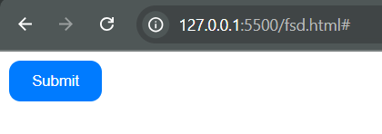

## Question 5: Layout with Flexbox

Task:  
Use Flexbox to:  
- Display items in a row.  
- Add space between them.

HTML Code:  
<div class="container">  
 <div>Item 1</div>  
 <div>Item 2</div>  
 <div>Item 3</div>  
</div>

CSS Code:  
.container {

display: flex;

justify-content: space-between;

}



## Question 6: Hover Card with Shadow

Task:  
Style the `.card` to:  
- Have a border and padding.  
- Add a box shadow on hover.  
- Set a smooth transition effect for the shadow.

HTML Code:  
<div class="card">  
 <h3>Product Title</h3>  
 <p>Some product description goes here.</p>  
</div>

CSS Code:

.card {

border: 1px solid #ccc;

padding: 20px;

transition: box-shadow 0.3s ease;

}

.card:hover {

box-shadow: 0 4px 8px rgba(0, 0, 0, 0.2);

}  
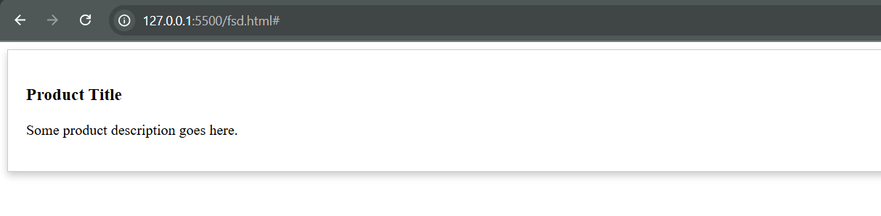

## Question 7: Style Even and Odd Rows Differently

Task:  
Use CSS to style even rows with a light background and odd rows with a white background.

HTML Code:  
<table>  
 <tr><td>Row 1</td></tr>  
 <tr><td>Row 2</td></tr>  
 <tr><td>Row 3</td></tr>  
 <tr><td>Row 4</td></tr>  
</table>

CSS Code:  
tr:nth-child(even) {

background-color: #f2f2f2;

}

tr:nth-child(odd) {

background-color: white;

}

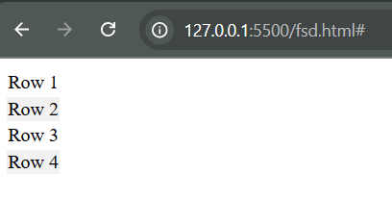

## Question 8: Positioning a Badge on an Image

Task:  
Place the `.badge` at the top-right corner of the image using positioning.

HTML Code:  
<div class="image-container">  
 <img src="product.jpg" alt="Product" width="200">  
 <span class="badge">New</span>  
</div>

CSS Code:

.image-container {

position: relative;

display: inline-block;

}

.badge {

position: absolute;

top: 10px;

right: 10px;

background-color: red;

color: white;

padding: 5px 10px;

font-weight: bold;

}  
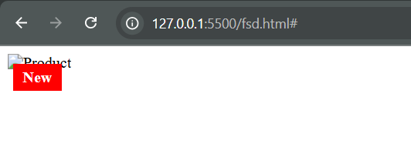

## Question 9: Responsive Text Size

Task:  
Use media queries to change the heading size:  
- Default: 32px  
- If screen width is below 600px: 20px

HTML Code:  
<h1 class="title">Responsive Heading</h1>

CSS Code:

  <style>

    .title {

      font-size: 32px; /* Default font size */

    }

    @media (max-width: 600px) {

      .title {

        font-size: 20px; /* Font size for screen width below 600px */

      }

    }

  </style>

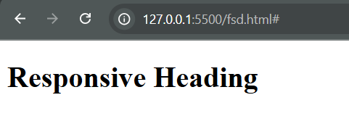  
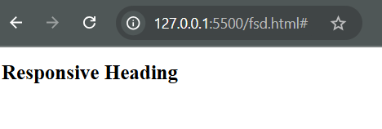

## Question 10: Navigation Menu with Active Link

Task:  
Style a navigation menu:  
- Inline horizontal layout.  
- Add spacing between links.  
- Highlight the active link with a border-bottom.

HTML Code:  
<nav>  
 <a href="#" class="active">Home</a>  
 <a href="#">About</a>  
 <a href="#">Services</a>  
</nav>

CSS Code:  
nav {

      display: flex;             /* Horizontal layout */

    }

    nav a {

      margin-right: 20px;        /* Space between links */

      text-decoration: none;     /* Remove underlines */

      color: black;              /* Default text color */

    }

    nav a.active {

      border-bottom: 2px solid blue; /* Highlight active link with border-bottom */

    }

